Let’s Build the Cloud, One Server at a Time!

GHC 2018 Workshop Instructions for Servers 1-11

Niharika Mateti, RADHIKA SAKSENA, AKANKSHA GUPTA

2018

Instructions for Servers labeled 1-11

**Before you begin**

1. **In this workshop you will be removing the components of a server and assembling it back. The workshop is for 30 minutes. You can take time to explore the server, but please ensure to put back all the components inside the server and close the top cover at the end of 30 minutes.**
2. Please take turns around the table for each instruction.
3. The round label on the top of the server shows the server model and generation. The printed instructions provided to you are for the model of the server on your desk. If you believe you may have received instructions for a different model, please bring it to the presenters’ attention.
4. **You may need to apply some force to snap things into place. But if you are applying too much force or if you are not able to pull the components out, then you are doing something wrong. Check the instructions and try again.**
5. There are volunteers around to help you if you require any assistance.
6. In most cases, you will not require a screwdriver. You should be able to loosen the thumbscrews easily. But if you need one, please ask the volunteers or the presenters for one.
7. Study Figure 1 to understand the system board components and their location.
8. On some servers there is additional information on the bottom side of the top cover.

**Removal Instructions**

1. Remove the top cover from the server.

* *Lift the latch on the top cover.*
* *Slide the cover toward the rear of the server and then lift to remove the top cover from the chassis.*

1. Remove the air baffle. The air baffle is a plastic cover that goes over the processors and memory.

* *See* Figure 4
* *Pinch in the battery pack side of the air baffle and lift the air baffle up and out of the server chassis.*

1. Remove the 2 RAM DIMMS.
   * *See* Figure 2 *for a picture of a DIMM.*
   * *Open the DIMM slot latches located at the edges.*
   * *Lift the DIMM up and out of the DIMM slot.*
2. Remove all the fans.
   * *See* Figure 8*.*
   * *Pinch together the two blue tabs on the top of the fan to release fan from the server chassis.*
   * *Pull the fan straight up and out of the server.*
3. Remove the power supply. Some servers have 2 power supplies, remove both of them. The power supplies are at the back of the server.
   * *See* Figure 12 *for a picture of the power supply.*
   * *Press the release tab toward the left.*
   * *Grasp the power supply handle and pull the power supply from the bay.*
4. Remove the PCI riser board assembly.
   * *See* Figure 6*.*
   * *Loosen the four thumbscrews that secure the PCI riser board assembly to the server chassis.*
   * *Lift up on the assembly to unseat the PCI riser boards from the system board and remove the PCI riser board assembly from the server.*
5. Remove the PCI card from the PCI riser board assembly.
   * *See* Figure 10 *and* Figure 11
   * *Carefully slide out the PCI card.*
6. Remove the hard drive.The hard drives are in the front of the server.
   * *Press the red ejector button to release the handle.*
   * *Use the handle to slide out the hard drive.*

**Installation Instructions**

1. Install the Fans.

* *See* Figure 9*.*
* *Grasp the fan by the blue tabs and align the fan over metal guide post, pins, and system board fan connectors.*
* *Lower the fan straight down into the server chassis.*
* *Push down and out on the blue tabs until the fan is fully seated and clicked into place.*

1. Install the 2 RAM DIMMs. Check the number of processors installed in your server. If only 1 processor is installed, place the 2 DIMMs according to the alphabetic order (A and B slot for installed processor). If 2 processors are installed, place each of the DIMMs in the A slot of each processor.
   * *Check* Figure 2 *for DIMM Installation and* Figure 3 *for DIMM Slots.*
   * *Ensure that the DIMM slot latches are open.*
   * *Locate the alignment notch on the DIMM and align it with the key in the DIMM slot.*
   * *Push the DIMM down firmly into the slot until the DIMM slot latches snap into place.*
   * *Ensure that the DIMM is fully inserted and properly seated in the slot.*
2. Insert the power supply into the power supply slot.
   * *See* Figure 12
   * *Slide the hot-plug power supply into the power supply bay until it is fully seated and clicks into place.*
3. Install PCI card into the PCI riser board.
   * *See* Figure 10*.*
   * *Gently slide the PCI card into an empty PCI slot on the PCI riser board.*
   * *Ensure that the PCI card is fully inserted and properly seated.*
4. Install the PCI riser board assembly.
   * *Check* Figure 7 *for installation of PCI riser board assembly.*
   * *Place the PCI riser board assembly on the system board.*
   * *Tighten the four captive thumbscrews that secure the PCI riser board assembly to the server chassis.*
5. Install the hard drive into bay 1. On some servers, check the front of the server for the hard drive bay numbering. On other servers there is a label on the top of the server which shows the hard drive bays numbering.
   * *Press the ejector button to release the handle.*
   * *With the hard drive handle extended, insert the drive into the drive bay.*
   * *Close the drive handle to lock the hard drive into place.*
6. Install the air baffle.
   * *See* Figure 5 *for air baffle installation.*
   * *Replace the air baffle into the server chassis.*
7. Replace the top cover.
   * *To replace the top cover, align it to the chassis then slide it toward the front panel. The air vents go at the back of the server.*
   * *The latch should be open while sliding the cover.*

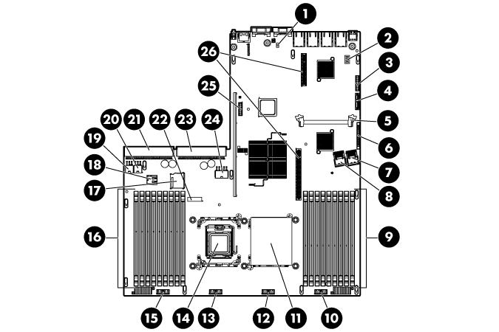**DL360 Gen7/DL360 Gen6 System Board Components**

Figure 1: DL360 Gen7/Gen6 System Board Components

|  |  |
| --- | --- |
| Item | Description |
|  |  |
| 1 | NMI jumper |
|  |  |
| 2 | System maintenance switch |
|  |  |
| 3 | 10Gb sideband connector |
|  |  |
| 4 | SATA DVD-ROM drive connector |
|  |  |
| 5 | SAS cache module connector |
|  |  |
| 6 | Power button connector |
|  |  |
| 7 | Hard drive data connector 1 (drives 1-4) |
|  |  |
| 8 | Hard drive data connector 2 (drives 5-8) |
|  |  |
| 9 | Processor 1 DIMM slots (9) |
|  |  |
| 10 | Fan module 4 connector |
|  |  |
| 11 | Processor socket 1 (populated) |
|  |  |
| 12 | Fan module 3 connector |
|  |  |
| 13 | Fan module 2 connector |
|  |  |
| 14 | Processor socket 2 |
|  |  |
| 15 | Fan module 1 connector |
|  |  |
| 16 | Processor 2 DIMM slots (9) |
|  |  |
| 17 | SD card slot |
|  |  |
| 18 | Internal USB connector |
|  |  |
| 19 | Hard drive power connector 1 |
|  |  |
| 20 | Hard drive power connector 2 |
|  |  |
| 21 | Power supply connector 1 |
|  |  |
| 22 | System battery |
|  |  |

|  |  |
| --- | --- |
|  |  |
| 23 | Power supply connector 2 |
|  |  |
| 24 | PCI power connector |
|  |  |
| 25 | TPM connector |
|  |  |
| 26 | PCIe riser board connectors (2) |
|  |  |
|  |  |

**Installation of a DIMM**

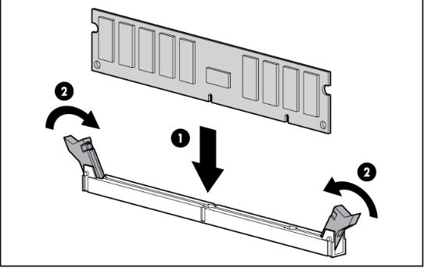

Figure 2: Install a DIMM

**DIMM Slots**

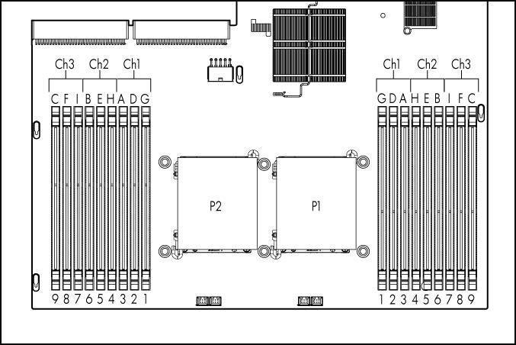

Figure 3: DIMM Slots

**Remove the air baffle**

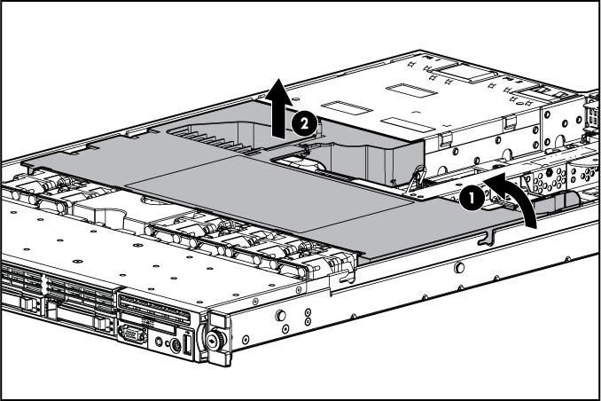

Figure 4: Air Baffle removal

**Install the air baffle**

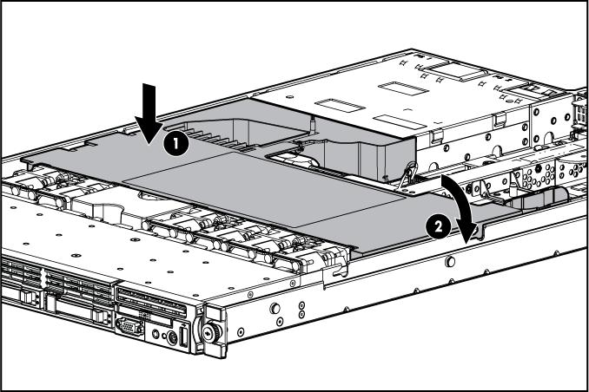

Figure 5: Air baffle installation

**Remove the PCI riser board Assembly**



Figure 6: Remove PCI Riser Board Assembly

**Install the PCI riser board Assembly**



Figure 7: PCI Riser Board Assembly Installation

**Remove Fans**



Figure 8: Fan removal

**Install Fans**



Figure 9: Fan installation

**Install the PCI Card**



Figure 10: PCI Card Installation

**PCI**

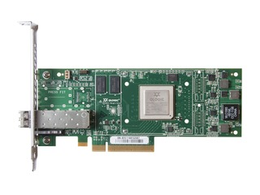

Figure 11: PCI expansion card

**Power Supply**



Figure 12: Insert Power Supply